Name: Jamie Anthony Brindle
Student ID: 06352322
Title: Website Development: Online Bookshop Assignment 1 Demonstration and Testing
Register New User

Register User From Almost Any Page on the Site:
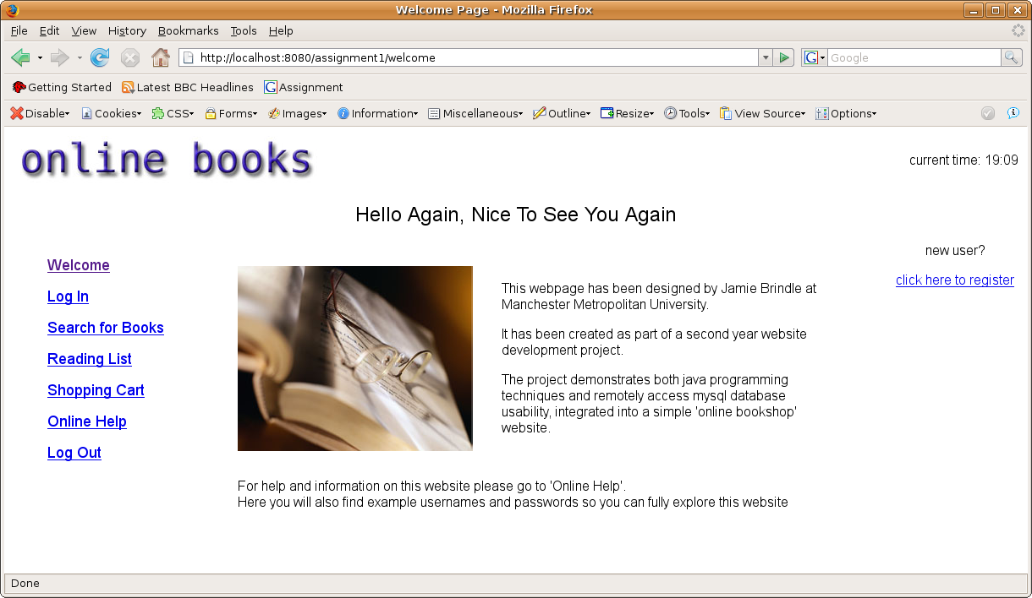
This options appears in almost every page so a user can quickly add an account if they wish

Register User: Enter Details
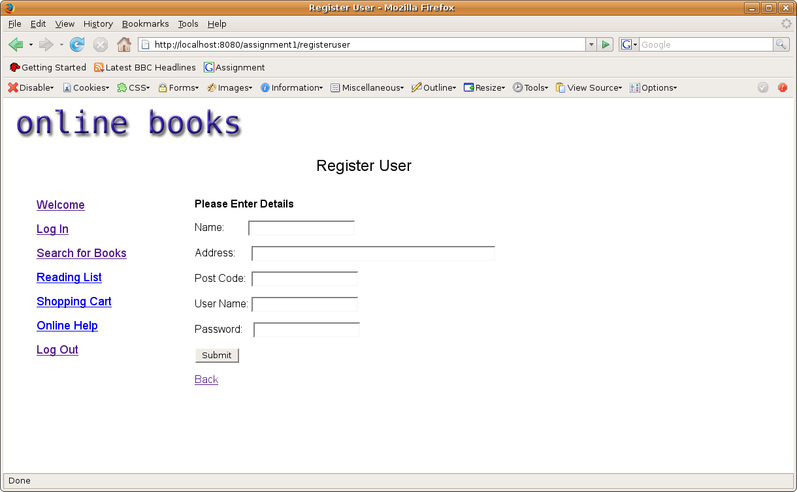
New users enter their details in editable text fields
Register User: Confirmation Unsuccessful due to user already registered with that user name
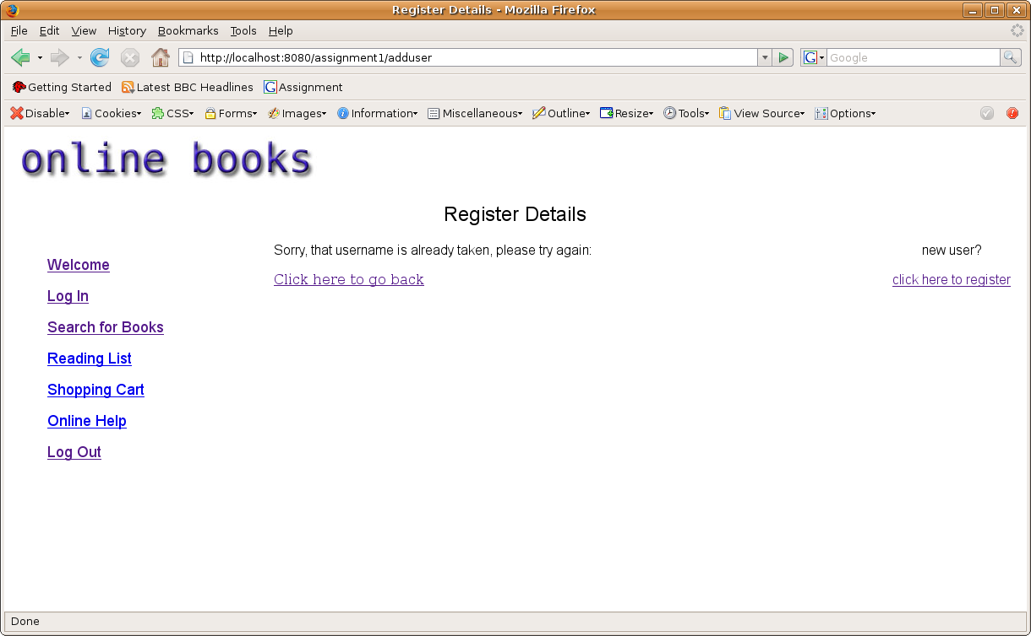
Error message appears asking user to try again

Register User: Confirmation successful
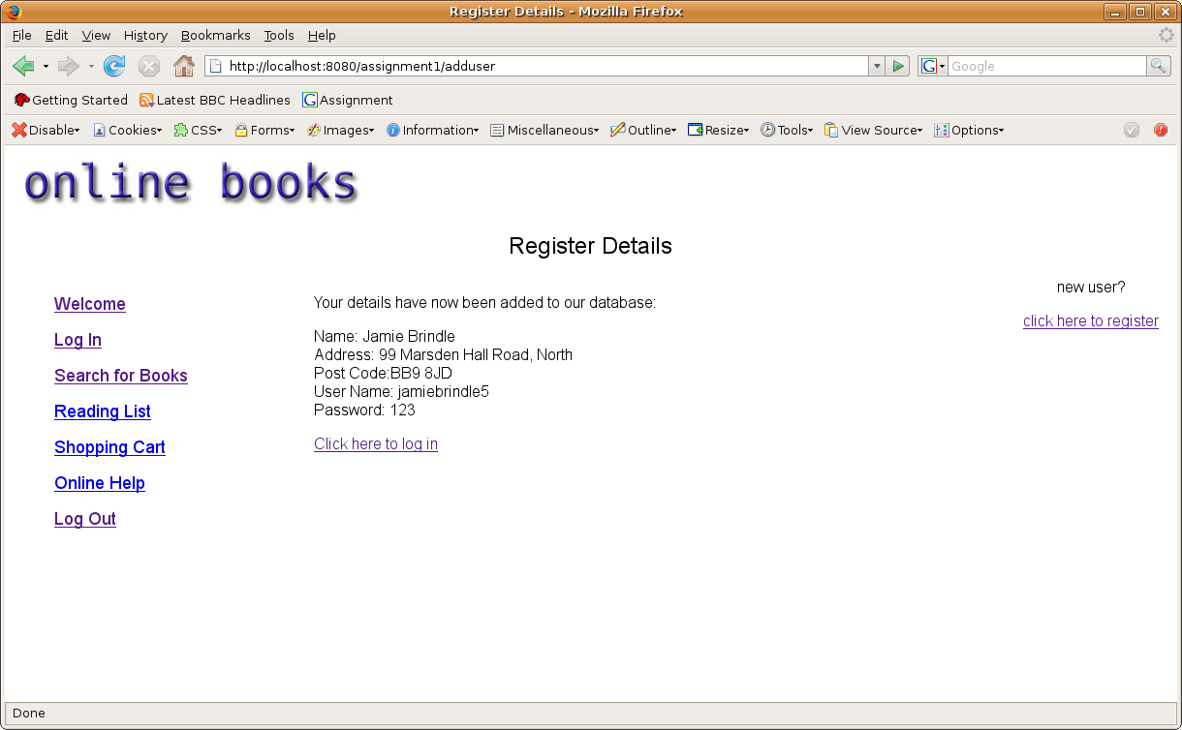
Confirmation that the user has been successfully added to the database

Register User: Double check the user can now log in
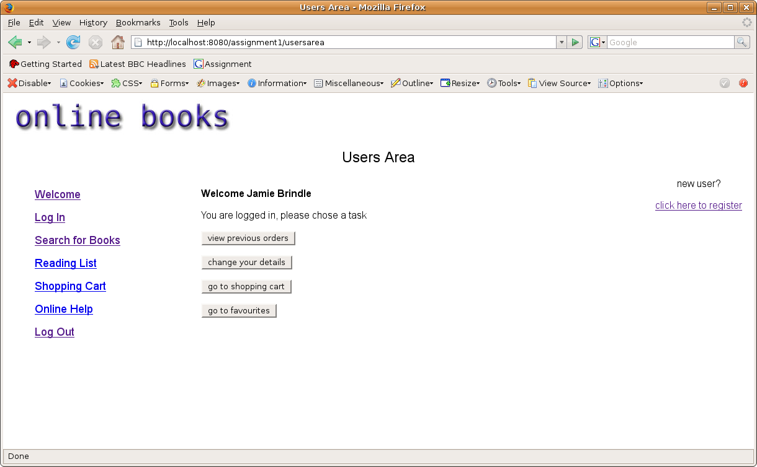
Login has been successful

